2. Identify the system calls to copy the content of one file toanother and
illustrate the same using a C program.
PROGRAM:
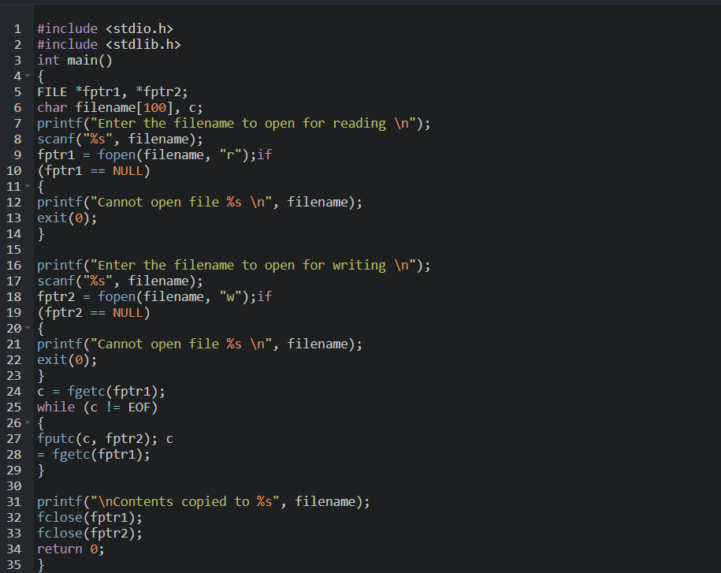

OUTPUT:


